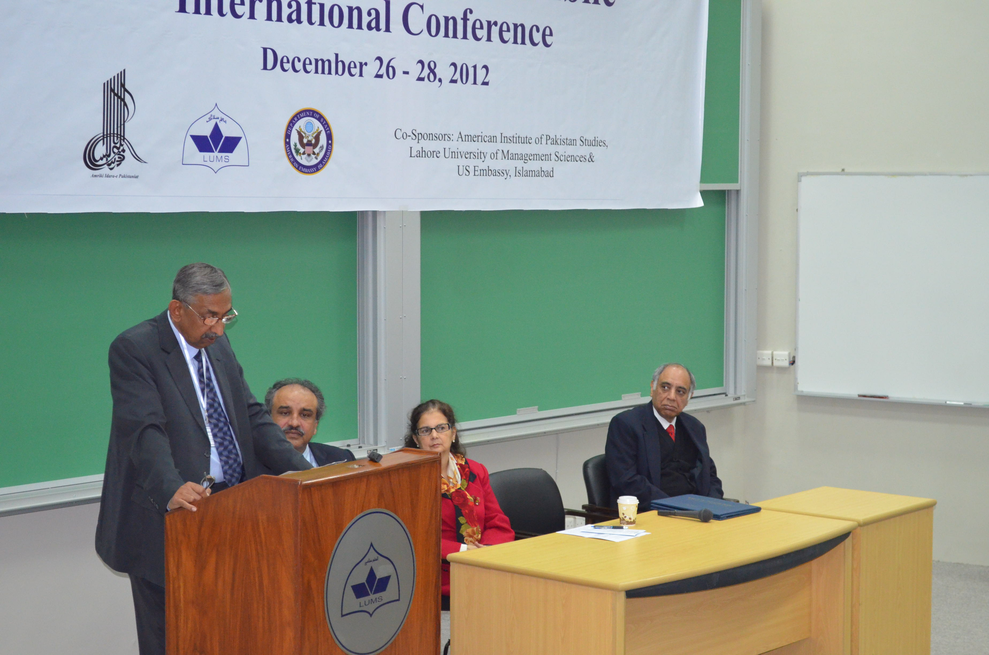
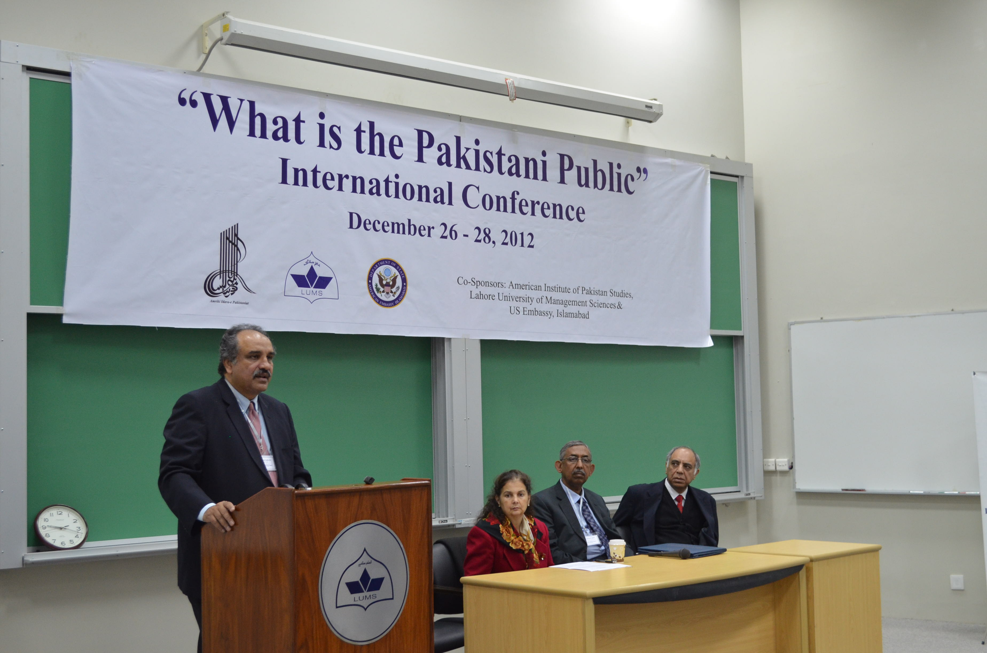
AIPS International Conference on
'What is the Pakistani Public?' Concludes Successfully

December 31, 2012
The American Institute of Pakistan Studies (AIPS) and the Public Affairs Section, US Embassy, arranged a three-day conference at the Lahore University of Management Sciences (LUMS). The conference was based on the question, ‘What is the Pakistani Public?’
The opening ceremony took place in Suleman Dawood School of Business where Dr. Anjum Altaf, Dean Mushtaq Ahmad Gurmani School of Humanities and Social Sciences (MGSHSS), CG Nina Fite, US Consulate, Mr. Kamran Asdar Ali, President AIPS, Mr Shehzad Iqbal, Sr. Joint Secretary, Ministry of Inter Provincial Coordination and Prof. Aamir Mufti, from University of California, Los Angeles gave remarks and talked about their expectations from the conference.
Dr. Altaf said he was ‘delighted and apprehensive’ at the same time about the conference. He was happy to meet individuals he could hold a discussion with and at the same was fearful because a ‘conference was needed to discuss this meta course.’ He urged the LUMS faculty members present to take the discussion to their classrooms and beyond LUMS.
Ms. Nina Fete, Counselor General US Consulate, added to Dr. Altaf’s remarks further by saying that changes in society are effecting how various spaces are being used by the public. Referring to the diverse participant backgrounds, she said that art and literature are the best tools to bridge society. CG Fete went on to say that Mr. Mohammad Ali Jinnah also promoted space and tolerance and founded a country on this vision and she was eager to see the outcomes of the conference’s discussions into the open space.
The conference was put together by AIPS who have been working in Pakistan since 1973. The organisation receives its funding from the US and Pakistan governments, bridging ties by promoting research and academics. AIPS has recently started a programme to develop junior faculty of public universities and help them polish their research and teaching skills.
Professor Aamir Mufti, of UCLA, summed the purpose of the conference by saying, ‘The aim is to bring together mature and young individuals to really think about the emergence of Public Policy of Pakistan.' He said the topic was proposed to broaden the limits of discussion thus including a wide variety of participants from literary academics to artists. Professor Mufti said the goal of the convention is to generate discussion and controversy to reach meaningful results.
The opening ceremony was attended by Syed Babar Ali, Pro Chancellor LUMS, Dr. Adil Najam, VC LUMS, Dr. Noman-ul-Haq, Faculty MGHSS, Professor Salima Hashmi, Dean Beaconhouse National University among others.
The second day, December 27, 2012 of the three-day conference entitled "What is the Pakistani Public?," was well received, featuring artists, scholars, writers and activists from the UK, the US, India and Pakistan.
Saloni Mathur of UCLA was chair person for day two of the conference and Naiza Khan, an independent artist and curator, kicked off the morning session with her The Streets are Rising presentation which was followed by Cornell University’s Iftikhar Dadi’s Art and the National Publics: The case of Sadequain.
Art critic and curator, Hammad Nasar, took the stage after Dadi. Nasar presented his compilation of Karachi’s street/local art Karachi Pop: Engaging Vernacular Visual-ties in 1990’s to the audience. Other speakers at the conference included renowned Pakistani columnist Suroosh Irfani, Sadia Abbas from Rutgers University, Naveeda Khan of John Hopkins and LUMS’ Farrukh Khan. Presentations were followed by a sightseeing tour of Wazir Khan Mosque and other inner city areas. The participants ended the day by dining in the old city.
Overall, the seminar was well received on its second day and the speakers were able to portray public opinion through art compilations. The participants praised LUMS for organising the event and one of them described it as ‘a tremendous effort from an institution which has been detached from art in recent times’. Another attendee appreciated the theme of the event and said, 'It was an excellent opportunity to brainstorm and create awareness about the different levels and aspects of modern art.'
Third day of the international conference hosted by the Mushtaq Ahmad Gurmani School of Humanities and Social Sciences at LUMS in collaboration with the American Institute of Pakistan Studies and the Public Affairs Section, US Embassy, took place in Suleman Dawood School of Business.
Rabia Nadir, Lahore School of Economics, and Dr. Noman ul- Haq of the Department of Humanities and Social Sciences at LUMS, were chair people for the last day of the conference. Third day of the conference was attended by historians, activists and artists, from Pakistan and abroad. Final day started with the focus shifting from art to politics; as speakers explored the political perspective of the question ‘What is the Pakistani Public?’
Notable historian Gyan Prakash of Princeton University commenced the first half of day three with “From the Public to the ‘People’: Perspectives on Colonial and Postcolonial Politics in Mumbai”. Other notable speakers included Will Glover from the University of Michigan, Fehmida Riaz (author and poet), Kamran Asdar Ali from University of Texas at Austin, renowned poet and author Asif Aslam Furrukhi.
The conference ended on the focus shifting to art and society. LUMS’s HSS faculty Dr. Ali Khan and Dr. Farrukh A. Khan were the concluding presenters. Dr. Ali Khan presented the interesting evolution of local film posters and their reflection in the cognitive evolution of the society. Dr. Farrukh also presented on the local film industry. His focus was on the ‘Maula Jutt’ fils and how the role of women is seen changing through the series. He also said that the concepts shown in these films were much beyond common enmity.
The three day conference received a lot of praise from the attendees and speakers, and University of Michigan’s Will Glover described it as “a great effort to bring together scholars and historians from different institutions and countries

