(panel 2 cont’d)
“Pakistani Public: Manifestations of a Religious Tradition”
Humeira Iqtidar, Kings College, London

5:00-5:30 Refreshments

5:30-7:00 Keynote Address
Mohammed Hanif, Author and Journalist

7:00 Dinner at LUMS

8:30-10:00 Cultural Evening

Thursday December 27, 2012

9:30-12:00 Panel 3- Chair: Saloni Mathur, UCLA

“The Streets are Rising”
Naiza Khan, Independent Artist and Curator
“Art and the National Publics: The Case of Sadequain”
Iftikhar Dadi, Cornell University
“Karachi Pop: Engaging Vernacular Visualities in 1990s Karachi”
Hammad Nasar, Art Critic and Curator, Asia Art Archive, Hong Kong

“Reclaiming the Forbidden: Iqbal, Jinnah and the 'Goddess'”
Suroosh Irfani, Beaconhouse National University

12:00-1:30 Lunch
1:30-3:30 Panel 4- Chair: Rabia Nadir, Lahore School of Economics

“From the Public to the ‘People’: Perspectives on Colonial and Postcolonial Politics in Mumbai”
Gyan Prakash, Princeton University
“Sikh Heritage Conservation as Public and Political Praxis”
Will Glover, University of Michigan
“The Attempts at the Gentrification of the Karachi Coastline”
Arif Hasan, Architect, Urban Planner, Author

Sightseeing of Wazir Khan Mosque and other Inner City areas.
Dinner in the City. Bus leaves at 4 pm. Organized by Rabia Nadir .

What is the Pakistani Public?

Wednesday December 26, 2012

9:00-10:00 Introductory Session

Kamran Asdar Ali
President AIPS, University of Texas at Austin

Professor Anjum Altaf
Dean, MAGSHSS, LUMS

The Honorable Nina Fite
Consul General, US Consulate, Lahore

Mr. Faridullah Khan
Federal Secretary, IPC Ministry

Aamir Mufti
UCLA

10:00-10:30 Refreshments
10:30-1:00 Panel 1- Chair: Asif Aslam Farrukhi, Author and Editor

“The Intellectual and His Publics”
Bilal Hashmi, NYU
“Poetic Counterpublics: Feminist Poetry and National Peripheries”
Shad Naved, UCLA
“‘Women’s Lyric’: Private Gestures to the Public”
Fatima Burney, UCLA
“The Possibility of Secular Criticism: Twenty-First Century Pakistani Film and Pop Culture”
Maryam Khan, UCLA
1:00- 2:30 Lunch
2:30-5:00 Panel 2- Chair: Kamran Asdar Ali, UT, Austin

“Dreams of a Secular Republic: Elite Alienation in Post-Zia Pakistan”
Aasim Sajjad Akhtar, Quaid-e-Azam University

“Colonial Law and the Constitution of a Muslim Public”
Asad Ahmed, Harvard University
“‘Anonymous Nation’: Foundation, Potential and Movement in Pakistan”
Tahir Naqvi, Trinity University

.
Friday December 28, 2012

9:00-11:00 Panel 5- Chair: Shahnaz Rouse, Sarah Lawrence College
"Art as Critique and the Constitution of a Public"
Sadia Abbas, Rutgers University
“Skepticism in Public Culture: From the Jahil Maulvi to Mullaism”
Naveeda Khan, Johns Hopkins University
“Apocalyptic Love Letter: Punjabi Culture, Self-Articulation and Subverting the Dominant Discourse in ‘Maula Jatt’”
Furrukh Khan, LUMS
11:00-11:30 Refreshments
11:30-1:30 Panel 6- Chair: Noman-ul-Haq, LUMS
“Why Pakistanis Never Became a Nation”
Fahmida Riaz, Author and Poet
“The Other Side of the ‘Tracks’: Sara Shagufta and the Politics of Gender and Class”
Kamran Asdar Ali, University of Texas at Austin
“Literature from Pakistan in the Public Sphere”
Asif Aslam Furrukhi: Author and Editor
1:30-3:00 Lunch and Friday Prayers
3:00-5:30 Round table discussion and wrap-up
Moderator: Aamir Mufti, UCLA
“Public Spaces 2.0: Re-imagining Culture and Engagement in Times of Fear”
Sabeen Mahmud, T2F
"Vanishing Artistic Wealth of Pakistan"
Umair Jaffar, IPAC

Ali Khan, LUMS

“Public Machines, PK”
Yasir Husain, Independent Artist and Activist
Dinner in the city.



What is the Pakistani Public?

Lahore, Pakistan
December 26-28, 2012


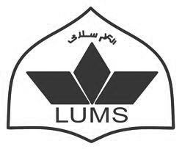
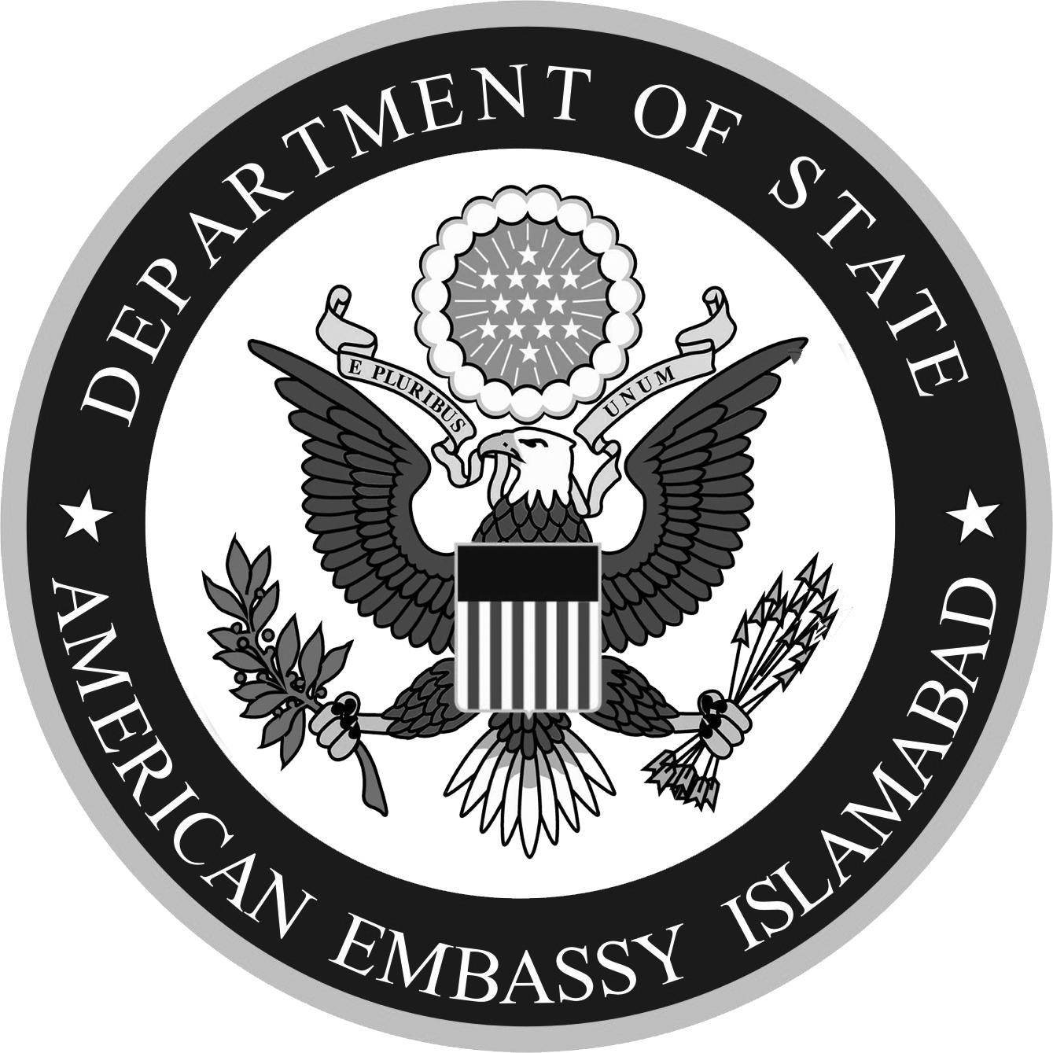
Sponsored by the American Institute of Pakistan Studies (AIPS); Mushtaq Ahmad Gurmani School of Humanities and Social Sciences, Lahore University of Management Sciences (LUMS); Public Affairs Section, US Embassy, Islamabad.

